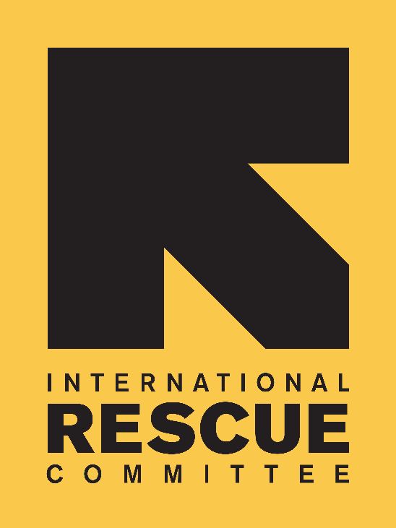
JOB DESCRIPTION

Position: Project Officer, COMPASS
Reports to: Programme Coordinator, COMPASS
Location: London
Salary: circa £30,000 per annum
Grade: 7
Hours: 37.5 hours
Duration: Fixed term contract to 30 November 2017

BACKGROUND
Over the past 80 years, the International Rescue Committee (IRC) has developed unparalleled expertise in responding to emergencies and helping uprooted communities to rebuild. Founded in 1933 at the request of Albert Einstein, the IRC offers lifesaving care and life-changing assistance to refugees forced to flee from war or disaster.

The International Rescue Committee UK is part of the IRC global network, which has its headquarters in New York and London. The IRC is on the ground in more than 40 countries, providing emergency relief, relocating refugees and rebuilding lives in the wake of disaster. Through 22 regional offices in cities across the United States, the IRC also helps refugees resettle in the US and become self-sufficient.

The IRC is committed to a culture of bold leadership, innovation in all aspects of our work, creative partnerships and, most crucially, accountability to those we serve. The IRC is a tireless advocate for the most vulnerable.

IRC-UK
Our European headquarters, IRC-UK, were established in London in 1997 to support the organisation’s global activities and particularly to diversify its donor base and be able to better advocate with European policy-makers on behalf of the people we serve. Since its establishment IRC-UK has grown rapidly and is now acknowledged for its high quality project management, technical expertise in governance and rights and economic recovery, and innovative thinking on early recovery and gender based violence. The IRC also has offices in Brussels, Berlin and Geneva. IRC-UK comprises approximately 90 staff across five departments.

VPRU Team
IRC was one of the first humanitarian organizations to launch specific programmes for survivors of sexual violence, implementing gender-based violence (GBV) programmes in refugee settings and other conflict-affected communities from 1996. Over the past 21 years, IRC has pioneered and implemented programmes that prevent and respond to violence against women and girls in refugee settings and in other conflict-affected contexts, making the IRC a global leader in this field. Under the Violence Protection and Empowerment Unit (VPRU), IRC presently implements women’s protection and empowerment programmes to support social and political environments that foster women’s freedom from violence, discrimination, and exclusion, allowing them to be active participants in rebuilding their countries. Today, IRC manages VPRU programmes in 30 countries across Africa, Asia, the Middle East and Haiti, with funding from governments, the UN, foundations, and private donors.

Team Chart

COMPASS Programme
COMPASS (Creating Opportunities through Mentorship, Parental Involvement and Safe Spaces) is a three-year project funded by the UK Department for International Development (DFID) which aims to improve prevention and response to violence against adolescent girls in humanitarian settings. The COMPASS programme is due to end in November 2017 and programme and research implementation is near completion, with substantial data and learning generated. The focus of the final months of the programme will be on sharing this learning with policy makers and practitioners.

The Purpose of the Role

Based in IRC’s UK office in London, the Project Officer will be responsible for providing programmatic, communication, logistical, and administrative support to the project. The Project Officer will report to the Project Coordinator and work closely with colleagues in IRC country programmes, communications team and policy & advocacy team.

Scope and Authority

Authority:
This position has authority to make decisions within the parameters of external and internal communications for the project and administrative management for IRC and the wider project Consortium. Any non-routine and complex matters should be referred to their line manager or director.
This position has authority to lead on contract drafting and approval processes including compliance issues.

Responsibility for Resources:
This position has responsibility for the following information resources:
- Dissemination project plan (creating and managing)
- Logframe (updates and revisions, collating and inputting data, narrative as required)Academic research articles (managing the authorship and approval process)
This position will be required to manage budgets for the development and/or design of specific project communications products and materials, as identified by the Project Coordinator.

Key Working Relationships

- Programme Coordinator (line manager) and Senior Technical Advisor, as needed.
- IRC policy & advocacy and communications colleagues.
- External liaison and representation as required (e.g. venues, editors, designs, printers etc.)
- IRC country programmes and technical advisors supporting the programme.
- Main point of contact for COMPASS research partner.

MAIN DUTIES AND RESPONSIBILITIES

Communications and dissemination (60%)
- Lead the internal and external communications for the COMPASS programme, including developing and managing a dissemination project plan.
- Develop project communications strategies including a schedule of communications and media events and targeted audiences for each.
- Project manage and coordinate public policy, practitioner and research events and meetings for COMPASS.
- Project manage the design, development, and production of information and communications materials and platforms (reports, publications, briefing materials, blogs etc.), liaising with internal teams and external consultants as necessary.
- Contribute to the ongoing development of dissemination strategies, liaising with the COMPASS project team, IRC policy & advocacy and communications staff, country offices, and academic partner as necessary.
- Lead and manage social media work for COMPASS.
- Support on development of learning products (e.g. briefs, presentations) for internal and external audiences.
- Support country teams with the design and implementation of country-level dissemination activities.
- Along with the Project Coordinator, Project Director and other staff, represent the project at external events and fora.

Programme management, M&E and reporting (20%)
- Support the Programme Coordinator to manage key programme management tools.
- Lead the implementation of the programme M&E framework and specifically support the COMPASS country teams to analyse data collected to inform programme adjustments and track and report process against the logframe.
- Support the Programme Coordinator with quarterly and final donor reporting process, including developing and consolidation of content as required.
- Undertake additional responsibilities as required, including providing support to other IRC VPRU projects outside of COMPASS.

Partner coordination (20%)
- Manage the relationship with research partner, ensuring that research products follow agree protocols and process in a timely and appropriate manner
- Develop and ensure adherence to the sign off process for all communication products
- Communicate with partners on administrative, contractual and compliance matters.

PERSON SPECIFICATION

Essential

Skills, Knowledge and Qualifications:
- Undergraduate degree in international development, gender, social work, public health, or other related field;
- Excellent written and verbal communication skills
- Excellent time management skills, ability to work to deadlines and strong attention to detail
- Understanding of programme management and monitoring and evaluation tools and approaches.
- Excellent level of personal organisation
- Ability to handle pressure and meet tight deadlines
- Proficiency in Microsoft Excel, Word, and PowerPoint
- Self-motivated, flexible and adaptable to the needs of the organisation

Experience
- Experience of working in a team to develop/implement internal or external communication plans/strategies.
- Experience disseminating research outputs and communicating complex research concepts to a range of audience
- Experience organising events for a range of audiences, from policy makers to practitioners
- Experience with developing communications products, including writing briefs, presenting findings and using social media
- Experience working in a communications, media or marketing role
- Experience working with researchers or academic institutions

Desirable
- Experience working or conducting research in a developing or humanitarian context, preferably focused on gender-based violence or adolescent girl issues;
- Experience working with DFID and/or other international donors;
- French language skills

To Apply
Please send a CV (two pages maximum) and cover page (two pages maximum) to: applications@rescue-uk.org

Please state clearly in your cover letter:
- Your reasons for applying
- How you meet the skills, knowledge and experience specified in the person specification part of the job description
- Where you saw the job advertised
- Current salary

The closing date is: 10am on Monday 7th July 2017

Interviews will be held W/C 10th July 2017

In order to minimise administrative costs, IRC-UK will only contact short-listed candidates.

Candidates must have the right to work in the UK.

IRC-UK strives to be an equal opportunities employer. IRC-UK is committed to equality of opportunity and to non-discrimination for all job applicants and employees, and we seek to ensure we achieve diversity in our workforce regardless of gender, race, religious beliefs, nationality, ethnic/national origin, sexual orientation, age, marital status or disability.

