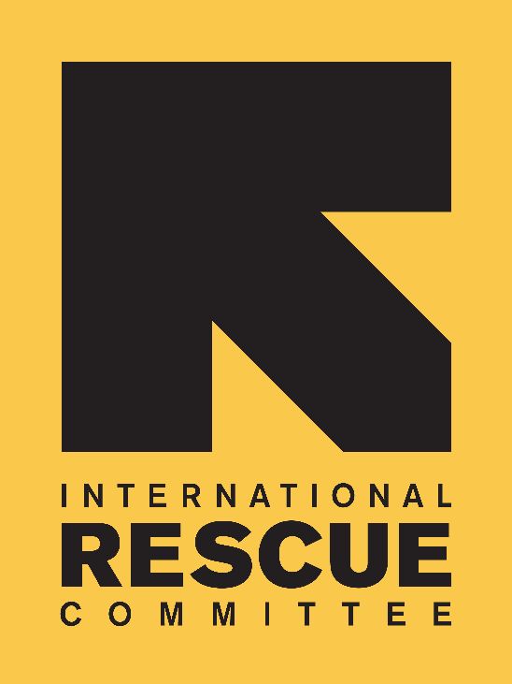
JOB DESCRIPTION

Position: Advocacy Officer
Reports to: Head of Advocacy
Location: London, UK
Salary: £30,000 per annum
Grade: 7
Contract: Fixed term (six months)
Hours: Full time. (37.5 hours / week)

BACKGROUND
Over the past 80 years, the International Rescue Committee (IRC) has developed unparalleled expertise in responding to emergencies and helping uprooted communities to rebuild. Founded in 1933 at the request of Albert Einstein, the IRC offers lifesaving care and life-changing assistance to refugees forced to flee from war or disaster.

The International Rescue Committee UK is part of the IRC global network, which has its headquarters in New York and London. The IRC is on the ground in some 40 countries, providing emergency relief and rebuilding lives in the wake of disaster. Through 28 regional offices in cities across the United States, the IRC also helps refugees resettle in the US and become self-sufficient.

The IRC is committed to a culture of bold leadership, innovation in all aspects of our work, creative partnerships and, most crucially, accountability to those we serve. The IRC is a tireless advocate for the most vulnerable.

IRC IN EUROPE
Our European headquarters, IRC-UK, were established in London in 1997 to support the organisation’s global activities and particularly to diversify its donor base and be able to better advocate with European policy-makers on behalf of the people we serve. Since its establishment, IRC-UK has grown rapidly and is now acknowledged for its high quality project management, technical expertise in economic recovery programmes, emergency response, and innovative thinking on early recovery and gender based violence. The IRC also has offices in Brussels, Berlin, Geneva, a sister organization in The Hague, and programme offices elsewhere in Europe.

THE POLICY & ADVOCACY DEPARTMENT

The core purpose of the Policy and Advocacy Department is to increase the IRC’s influence and profile, developing the IRC as a thought leader in Europe that can drive transformational change in the humanitarian sector. We aim to drive policy change to improve outcomes for people living in, and displaced by, conflict and crisis.

Team Chart

The Purpose of the Role
The Advocacy Officer will be responsible for building IRC’s profile and influence with the UK Government, Parliament and other relevant influencers to help improve outcomes for those affected by conflict and crisis. Working closely with relevant IRC staff in Europe and elsewhere, this post will help to develop and implement advocacy strategies that bring about real change.

Scope and Authority
Authority:
- Represent the IRC at external advocacy meetings, events, forums and in coalitions.
- Manage Advocacy interns as appropriate.

Key Working Relationships
- Report to the Head of Advocacy.
- Work together with Policy, Advocacy and Technical Unit colleagues in Europe and elsewhere to help develop advocacy strategies, with clear and succinct advocacy messages and products, from more complex policy and technical documents.
- Close coordination with the IRC Europe Communications team on the development of suitable communications products to deliver on advocacy objectives.
- Work with the European Strategic Partnerships Team on engagement with key stakeholders.

KEY ACCOUNTABILITIES

Building IRC’s profile and influence; effective advocacy for change (70%)
- Support the development of advocacy strategies and their implementation, coordination, information sharing and product development.
- Build IRC’s credibility, influence and relationships with the UK Government, Parliamentarians and other key targets in support of advocacy strategies on IRC’s priority issues.
- Ensure that IRC and our priority issues have a strong profile in the UK Parliament and with other relevant influencers.
- Support our wider influencing work in partnership with IRC colleagues in Europe and elsewhere.
- Spot and deliver on external opportunities to advance IRC’s policy and advocacy objectives.
- Provide input into policy analysis and development on a range of agreed issues, and work with Policy and Technical Unit colleagues to produce advocacy briefings, reports and other materials.
- Draft briefing papers, submissions to government consultations, and other materials for advocacy.
- Represent IRC externally and work alongside colleagues in other NGOs in both formal and informal coalitions to advance joint advocacy objectives.
- Contribute to the operations of the Policy and Advocacy Department, including the delivery of ad hoc project work.

Support for strategic planning and reporting to Board (15%)
- Create and maintain internal systems, including contact database, diaries of upcoming events and opportunities.
- Monitor and record IRC UK’s impact with the UK Government and Parliament, and potentially with others in Europe.
- Provide updates and information on policy and advocacy work to assist with reporting to board members and potential donors.

Events, communications and fundraising (15%)
- Work with the Communications and Fundraising teams to help pursue opportunities for funding for IRC programmes and for advocacy.
- Organise events on key IRC issues.
- Work closely with the IRC Europe Communications team to help develop and coordinate policy and advocacy products, and public campaigns on IRC priority themes and countries.
- Identify and attend priority contact groups and forums in the UK and Europe to deliver policy change related to priority countries and crises.
- Any other tasks appropriate to the role.

PERSON SPECIFICATION

Essential
Skills, Knowledge and Qualifications:
- Masters degree, ideally, in a subject related to IRC’s work (e.g. Development Studies, International Relations, Law, Refugee or Migration Studies, Conflict Studies) or equivalent experience.
- Good knowledge of Parliament and Whitehall, the UK policy landscape and key advocacy targets, and processes governing humanitarian aid and development policy

- Excellent writing and communication skills in English, and the ability to translate complex material and data into coherent narratives
- Strong networking and presentation skills
- Excellent analytical skills, and attention to detail
- Strong organisational and administrative skills
- Commitment to team work
- The ability to travel, to work to tight deadlines, and on own initiative
- Commitment to women’s rights and to the IRC’s vision, missions and values

Experience:
- Experience of working either in parliament, in Whitehall, or in a relevant public affairs role
- Proven experience of developing and implementing successful political influencing strategies to achieve results – including in working closely with communications colleagues to shape opinion
- Understanding of the UK NGO sector, experience of working in national or international coalitions
- Experience of working on complex policy issues, ideally on migration, home affairs, humanitarian issues and/ or foreign affairs
- Experience of working as part of an cross-organisational team to deliver on projects/ strategies, and of quickly forming effective working relationships to deliver results
- Highly motivated self-starter

Desirable
- Useful political and institutional contacts
- Fluency in a European language other than English

To Apply
Please send a CV (two pages maximum) and cover page (two pages maximum) to:
applications@rescue-uk.org

Please state clearly in your cover letter:
• Your reasons for applying
• How you meet the skills, knowledge and experience specified in the person specification part of the
job description
• Where you saw the job advertised
• Current salary

The closing date is: 9am on Monday 7th August 2017.

Interviews will be on Friday 11th August 2017.

In order to minimize administrative costs, IRC-UK will only contact short listed candidates.

Candidates must have the right to work in the UK.

IRC-UK strives to be an equal opportunities employer. IRC-UK is committed to equality of opportunity and to non-discrimination for all job applicants and employees, and we seek to ensure we achieve diversity in our workforce regardless of gender, race, religious beliefs, nationality, ethnic/national origin, sexual orientation, age, marital status or disability.

