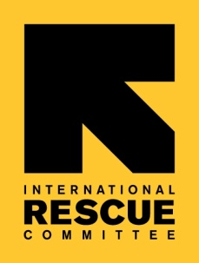
TERMS OF REFERENCE / SCOPE OF WORK

Introduction

IRC-UK is committed to ensuring we follow best practice in aid transparency. In order for us to meet this target we require the support of a consultant with significant experience and understanding of the International Aid Transparency Initiative and donor rules and regulations related to aid transparency, particularly DFID and the Dutch Ministry of Foreign Affairs.

Key Stakeholders and Relationships
- Accountable to Africa Grants Manager
- Close coordination with AMU Post-Award Team, IRC-UK Finance Team, SV, Communications Team
- Close working relationship with the field – Sierra Leone, Uganda

Core Consulting Tasks

The consultant will be expected to ensure the compliance of IRC-UK with DFID’s Minimum Standards of Publishing to IATI. As well the consultant will be expected to identify gaps in IRC-UK’s transparency based on best practice in the field to inform a TOR for a longer term position.

Key outputs

We expect the following tasks to be completed within one week:

- Transfer all IRC-UK data from csv2iati to Aid Stream
- Ensure all IRC-UK data is correct and up to date on the IATI Standard, using Bond’s assessment as a starting point
- Work with AMU Post-Award Team to ensure accuracy and completeness of all information published to the IATI Standard
- Ensure all required DFID grants are published correctly on Dev Tracker
- Write Terms of Reference for IRC Transparency Focal Point to ensure compliance with donor regulations and best practice in field based on current state of IRC-UK
- Working with all stakeholders propose system for regular publishing of data to IATI standard

Applications

Please submit your cover letter, CV and proposed fee rate to applications@rescue-uk.org by November 11th, 2016. Applications will be reviewed on a rolling basis until a suitable candidate is identified and so interested applicants are encouraged to submit an application as soon as possible.

